

**cDOT Archive Log Pruning Script – Troubleshooting Guide**

**Synopsis:** This document details the working of the cDOT Archive Log Pruning script and describes the troubleshooting steps.

**Authors:** Arpit Roy

**Document Version:** V1

**Date:** 3 September 2018

**Document Status:** Published

**CONFIDENTIAL INFORMATION**

This document contains information proprietary to Thomson Reuters and may not be reproduced, disclosed or used in whole or part without express permission of Thomson Reuters.

© Thomson Reuters 2018

Contents

1.1 Introduction 3

1.2 Change History 3

1.3 Initial Distribution List 3

1.4 Script Install Instructions 3

1.5 Script Path Locations 4

1.6 Script Troubleshooting Steps 4

# 

## Introduction

The script is scheduled to run every midnight from the regional jump servers via an entry at /etc/crontab.

It queries the MSIL storage for a specific naming convention of vservers and volumes and dumps it in a response.json file on the jump server.

A python sub-script then picks only the volume|vserver names from the response.json file. It then removes the root volumes from the list and stores the values in an array.

Once a list of vservers|volume is ready it adds any new entries to an automount file on the jump server.

The script then runs through each vserver|volume using the automount feature and prunes any files older than the specified retention date.

The retention date is determined based on the volume name. If no retention date is found it assumes a default of 14 day retention.

All files that are removed are stored in a log file. This log file is then compressed once all pruning is completed to reduce space each log file takes up.

Log files are located locally on each jump server at /filers/admin/scripts/support/pruning_conf/log on a per-date basis.

## Change History

|  |  |  |  |
| --- | --- | --- | --- |
| **Ver** | **Date** | **Author** | **Key Changes** |
| 1 | 9/3/2018 | Arpit Roy | Initial Version |

## Initial Distribution List

|  |  |
| --- | --- |
| **Name** | **Role** |
| STORAGE-ENGINEERING-FR | Reviewer |
| STORAGE-SUPPORT-FR | Reviewer |

## Script Install Instructions

Create the following directories on the jump server if they don't exist

* mkdir /archlog_prune_mnt
* mkdir /filers/admin/scripts/support/pruning_conf
* mkdir /filers/admin/scripts/support/pruning_conf/log
* mkdir /output-data/scriptoutput/arclog_out
* Create /etc/auto.archlogprune file

echo >/etc/auto.archlogprune

* Add line to /etc/auto.master file:

echo "/archlog_prune_mnt /etc/auto.archlogprune -retry=60,soft,intr,bg" >>/etc/auto.master

* Restart autofs service

/etc/init.d/autofs restart

* Add crontab entry manually using 'vi /etc/crontab' and add the two lines to the bottom of the file if it doesn’t exist.

#Archlog pruning script

0 0 * * * root /filers/admin/scripts/support/cdot_archivelog_pruning.sh

## Script Path Locations

Scriptname = cdot_archivelog_pruning.sh

scriptrun = /filers/admin/scripts/support/

scriptconf = /filers/admin/scripts/support/pruning_conf

pruning_path = /archlog_prune_mnt

log_prune_automount_file = /etc/auto.archlogprune

log_path = /filers/admin/scripts/support/pruning_conf/log

Json_parser_script = /output-data/scriptoutput/arclog_out/json_parser.py

Json_parser_output = /output-data/scriptoutput/arclog_out/out

## Script Troubleshooting Steps

1. Verify all the script directories are created as mentioned in section 1.4
2. Depending on the Jump server, verify if the MSIL API queries are returning a valid response. Below are the API queries based on the jump servers

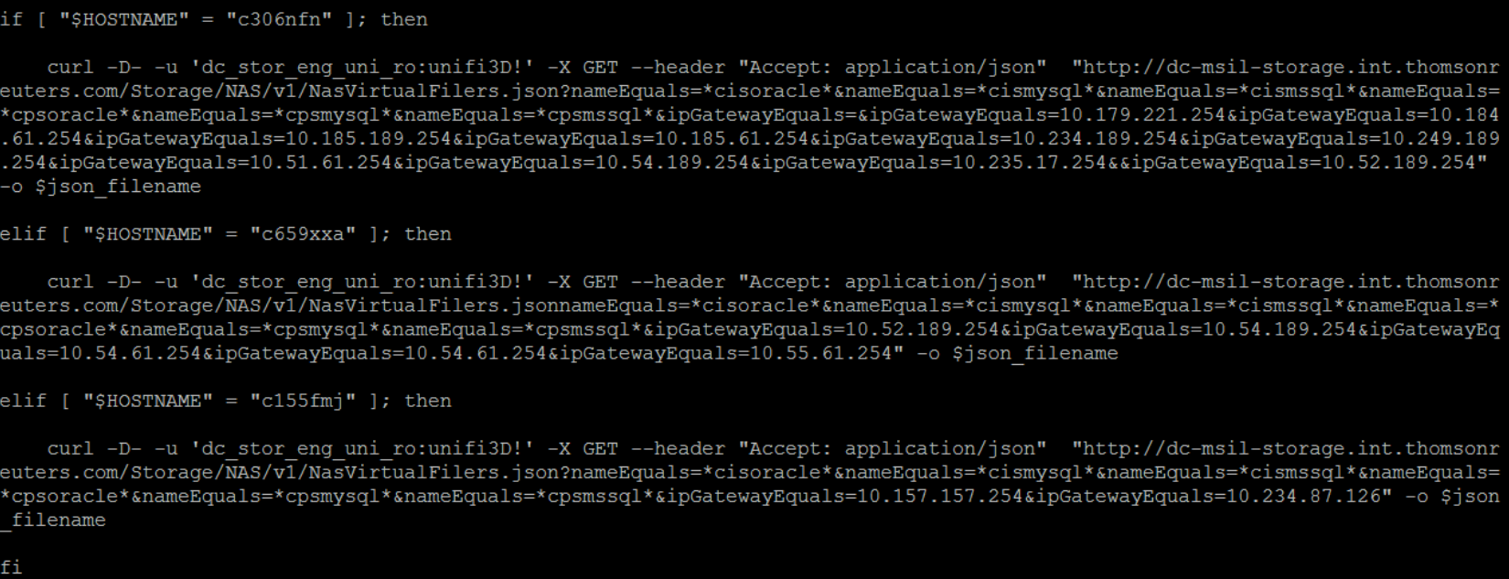

**Example**

To verify, copy the API query and run it on a web browser. Use the user name and password as below:

**URL**: [http://dc-msil-storage.int.thomsonreuters.com/Storage/NAS/v1/NasVirtualFilers.json?nameEquals=*cisoracle*&nameEquals=*cismysql*&nameEquals=*cismssql*&nameEquals=*cpsoracle*&nameEquals=*cpsmysql*&nameEquals=*cpsmssql*&ipGatewayEquals=&ipGatewayEquals=10.179.221.254&ipGatewayEquals=10.184.61.254&ipGatewayEquals=10.185.189.254&ipGatewayEquals=10.185.61.254&ipGatewayEquals=10.234.189.254&ipGatewayEquals=10.249.189.254&ipGatewayEquals=10.51.61.254&ipGatewayEquals=10.54.189.254&ipGatewayEquals=10.235.17.254&&ipGatewayEquals=10.52.189.254](http://dc-msil-storage.int.thomsonreuters.com/Storage/NAS/v1/NasVirtualFilers.json?nameEquals=*cisoracle*&nameEquals=*cismysql*&nameEquals=*cismssql*&nameEquals=*cpsoracle*&nameEquals=*cpsmysql*&nameEquals=*cpsmssql*&ipGatewayEquals=&ipGatewayEquals=10.179.221.254&ipGatewayEquals=10.184.61.254&ipGatewayEquals=10.185.189.254&ipGatewayEquals=10.185.61.254&ipGatewayEquals=10.234.189.254&ipGatewayEquals=10.249.189.254&ipGatewayEquals=10.51.61.254&ipGatewayEquals=10.54.189.254&ipGatewayEquals=10.235.17.254&&ipGatewayEquals=10.52.189.254)

**Username:** dc_stor_eng_uni_ro

**Password:** unifi3D!

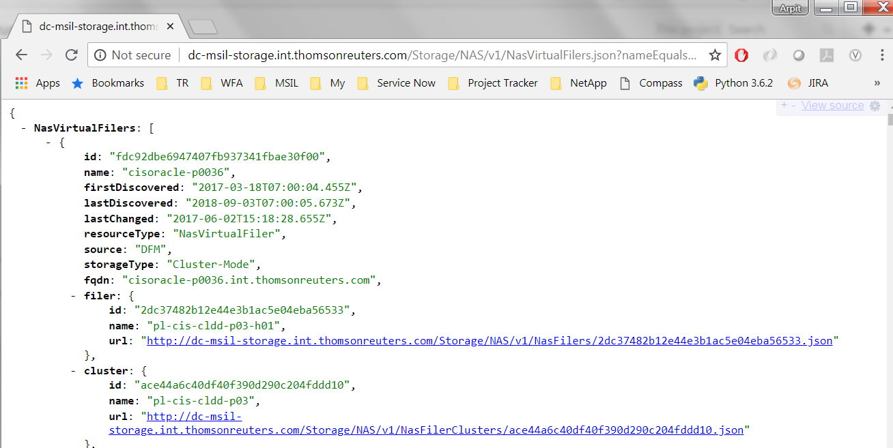

1. Verify if the ‘out’ file (/output-data/scriptoutput/arclog_out/out) is being generated which contains the volume/vserver information. These are the volumes that will be pruned based on retention.

**Example:**

c306nfn:/home/m6045647 # cat /output-data/scriptoutput/arclog_out/out | tail -10

cisoracle-d0039 cb0603_at_ccf467u_14_n01oraarch1_nosnap

cisoracle-d0039 cb0628_at_internalDB510t_14_n02oraarch1_nosnap

cisoracle-d0039 cb0603_at_shadowam1u_7_n02oraarch1_nosnap

cisoracle-d0039 cb0179_ct_cds569p2_14_n01oraarch1_nosnap

cisoracle-d0039 cb0332_at_tremor_cams597p_14_n01oraarch1_nosnap

cisoracle-d0039 cb0492_infra_opt1p_7_n01oraarch1_nosnap

cisoracle-d0039 cb0538_fnr_evm796p1_14_n01oraarch1_nosnap

cisoracle-d0039 cb0296_trta_indirect_tax5a_7_n01oraarch1_nosnap

cisoracle-d0039 cb0296_trta_indirect_tax6a_7_n01oraarch1_nosnap

cisoracle-d0039 cb0644_trl_firmcentuk816h_14_n01oraarch1_nosnap

1. Make sure that these volumes are exported to the specific jump box. If not exported, the volumes cannot be mounted and the log pruning will not happen.
2. Check the /etc/auto.archlogprune file and verify if the volumes are present.

**Example:**

Checking for cb0603_at_ccf467u_14_n01oraarch1_nosnap in the /etc/auto.archlogprune file

c306nfn:/home/m6045647 # **cat /etc/auto.archlogprune | grep cb0603_at_ccf467u_14_n01oraarch1_nosnap**

cisoracle-d0039__cb0603_at_ccf467u_14_n01oraarch1_nosnap cisoracle-d0039:/cb0603_at_ccf467u_14_n01oraarch1_nosnap

c306nfn:/home/m6045647 #

1. Make sure that the below line is added to the /etc/auto.master file. If not, follow the installation instructions in section 1.4 and add it.

c306nfn:/home/m6045647 # cat /etc/auto.master | tail -1

/archlog_prune_mnt /etc/auto.archlogprune -retry=60,soft,intr,bg

1. Identify if the logs have been generated for the last script run. Logs are saved based on the date.

c306nfn:/filers/admin/scripts/support/pruning_conf/log # ls -ltr | grep 09_03_2018

drwxrwxrwx 2 root root 4096 Sep 3 00:25 **09_03_2018**

1. Open the log directory and check if logs are present.

c306nfn:/filers/admin/scripts/support/pruning_conf/log/09_03_2018 # ls -ltr

total 23108

-rw-r--r-- 1 root root 1263257 Sep 3 11:13 09_03_2018_prune_log_**45**_ret

-rw-r--r-- 1 root root 9401703 Sep 3 13:51 09_03_2018_prune_log_**7**_ret

-rw-r--r-- 1 root root 325196 Sep 3 13:51 09_03_2018_prune_run_log

-rw-r--r-- 1 root root 12547854 Sep 3 14:41 09_03_2018_prune_log_**14**_ret

The highlighted log file contains the details of the volumes that have been pruned.

You can view the other 3 log files to find out which logs were pruned based on retention for a volume

Example:

09.03.2018_H00.M00.S29 | Pruning logs older than 7 on cisoracle-d0035|cb0667_plt_newslynx1149d_7_n01oraarch1_nosnap.

rm /archlog_prune_mnt/cisoracle-d0035__cb0667_plt_newslynx1149d_7_n01oraarch1_nosnap/ord1149a/LOG_962437279_11388_1.ARC

1. **Only when all the above steps have been verified and if you still see any issue with the pruning process, send an email to** [arpit.roy@thomsonreuters.com](mailto:arpit.roy@thomsonreuters.com) **with the following information:**

* **Issue description**
* **When was the issue first observed?**
* **Troubleshooting already performed**
* **Impact**